**DENTAL HEALTH - “What is Plaque?”**

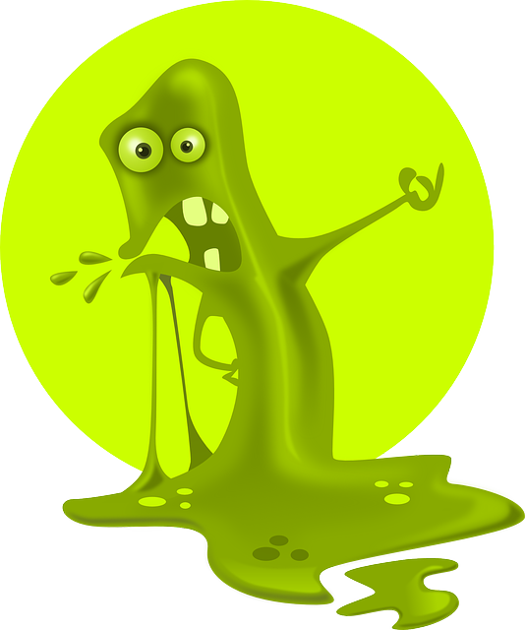

**PLAQUE** is a sticky, slimy substance made up of mostly germs that cause cavities in your teeth. A **cavity** is a hole in your tooth caused by plaque mixing with **sugars** from foods causing **acid.**

**PLAQUE+ SUGAR= ACID which causes a CAVITY**

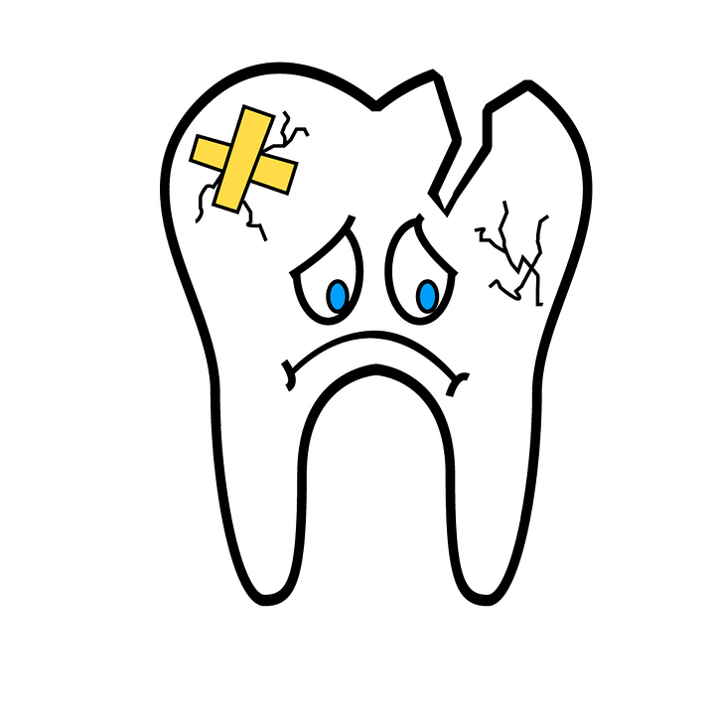

**How do you remove plaque from your teeth?**



**YOU CAN REMOVE PLAQUE BY:**

1. **BRUSHING YOUR TEETH WITH FLUORIDE TOOTHPASTE: Brush your upper teeth, lower teeth, tops, bottoms. Try to reach all your teeth even the ones in the back. Use circular or up and down motions and don’t press too hard. Did you brush your teeth today? Try to brush your teeth at least 2 times a day! If not, ask an adult if you can do it now.**
2. **FLOSSING YOUR TEETH WITH FLOSS. FLOSS IS A STRING THAT YOU PLACE INBETWEEN YOUR TEETH TO REMOVE PLAQUE AND LEFT-OVER FOOD. THE FLOSS IS MOVED BETWEEN YOUR TEETH. OLDER FAMILY MEMBERS CAN HELP YOU TO FLOSS IF IT IS TOO DIFFICULT.**
3. **USE A MOUTHWASH OR RINSE: Swirl the mouthwash in your mouth. DO NOT SWALLOW. Spit mouthwash or dental rise into the sink.**

**\*\*\*Can you name the different ways to remove plaque from your teeth? Circle the pictures and say them aloud. Second graders can write the word next to the picture**

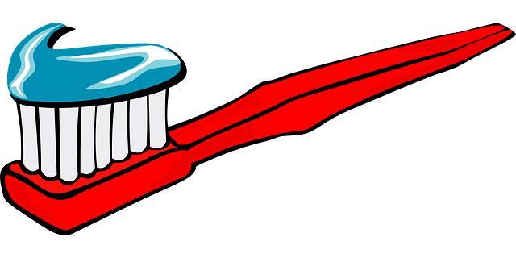 **________________________________________**

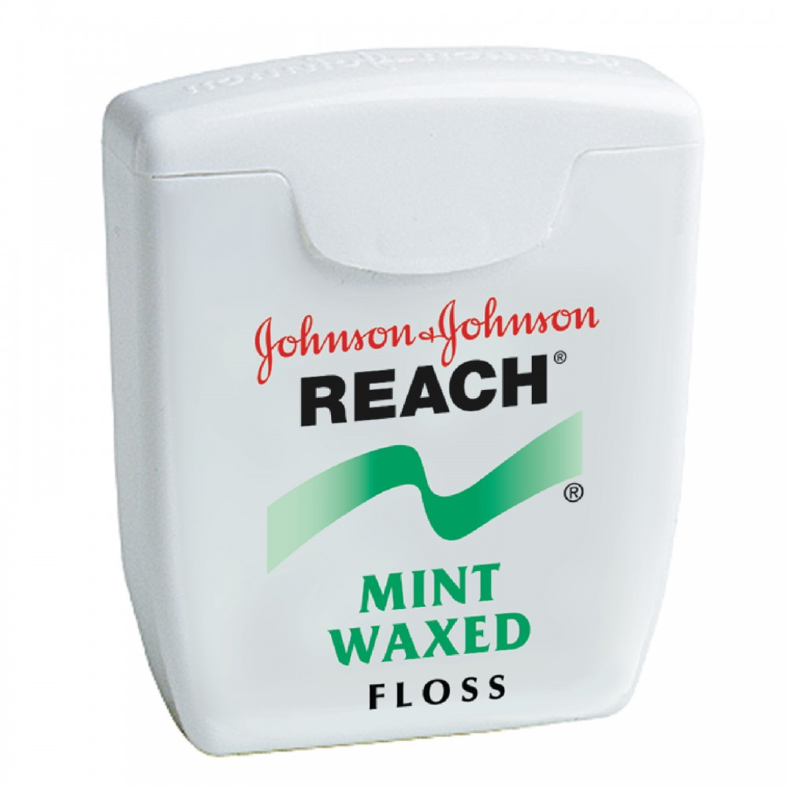  **___________________________________________**

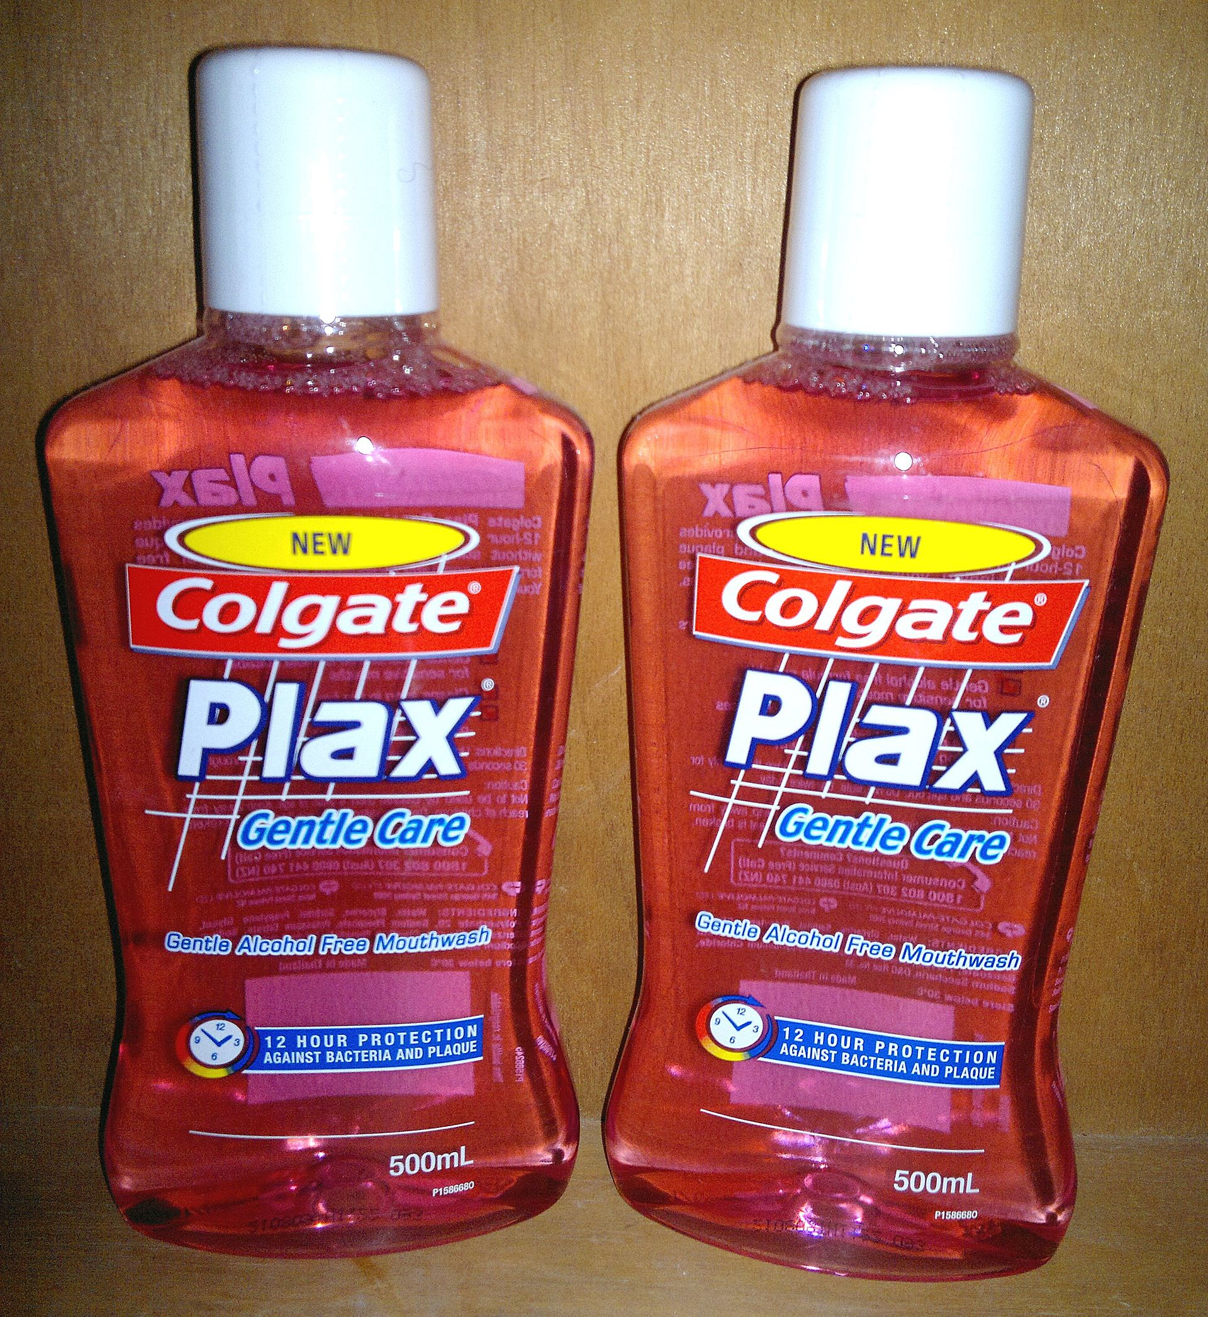  **____________________________________________**

**Please CLICK this link:** [**https://youtu.be/mxvDny_OwE0**](https://youtu.be/mxvDny_OwE0) **and watch the Tooth Defender Video! Everyone can be a Tooth Defender and fight cavities!!! I love CHOMPERS!!! Please send a message that you completed the health lesson on DOJO or send email to:** [**MillerA@dvsd.org**](mailto:MillerA@dvsd.org) **or** [**FeissJ@dvsd.org**](mailto:FeissJ@dvsd.org) **😊**